Foundations of Robotics – Lecture 9 Robot Navigation

Overview
Linking to learning outcomes

- LO2 – Criterion3: Understand and analyse dynamic physical robotic systems – control
and planning theory
- LO3 – Criterion 4: Understand the key features of basic hardware and control
software for a robotic system - Control and planning practice
In this lecture (continuing from the navigation behaviours):
- Algorithms for wall-following behaviours
- Ant Navigation – Finding Path to Food
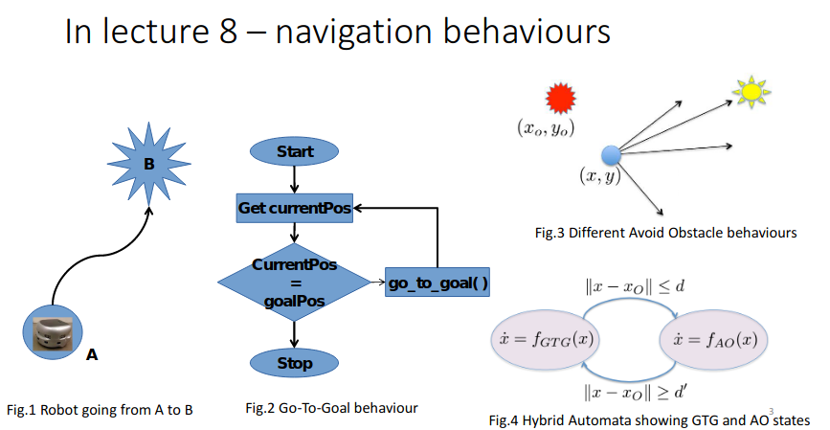
Algorithms for Wall Following Behaviours

Algorithms
- Simple wall following
- Wall following with direction
- Pledge algorithm
Assuming these sensing capabilities are available
- Goal detection
- Frontal and lateral wall detection
- Corner detection

